CHEM-371 ENSTRUMENTAL ANALYSIS LABORATORY

NEUTRALIZATION TITRATIONS BY POTANTIOMETRIC METHOD
LAB REPORT

Instructors: Prof. Dr. Recai İNAM Leader of Experiment: Dr. Elvan HASANOĞLU ÖZKAN
Name & SURNAME: Date:
ID: Section:
THE PURPOSE OF THE EXPERIMENT:

PROCEDURE:

DATA AND CALCULATIONS:
- Titration of strong acid (X M 25mL HCl) by strong base (0.2000 M NaOH)

- Titration of weak acid (X M 25 mL CH₃COOH) by strong base (0.2000 M NaOH)
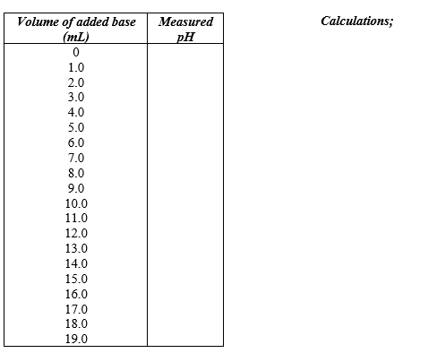

3. Titration of unknown acidic solution (32 mL) by strong base (NaOH)
CH₃COOH (X M) +HCl (0.0100M )/ (0.0500 M NaOH)
Graphic;
- Titration curve by the 3th titration
RESULTS AND DISCUSSION
- For the 1st Experiment (Titration of strong acid by strong base)  Equivalence point;  Experimental: ????? mL NaOH  Theoretical: ????? mL NaOH  Error %: | - For the 2nd Experiment (Titration of weak acid by strong base)  Equivalence point;  Experimental: ????? mL NaOH  Theoretical: ????? mL NaOH  Error %:
- For the 3th Experiment
Vtoplam= 32 mL

V_{HCl}=? V_{CH3COOH}= ? M_{CH3COOH]} ?

CONCLUSION:

REFERENCES

